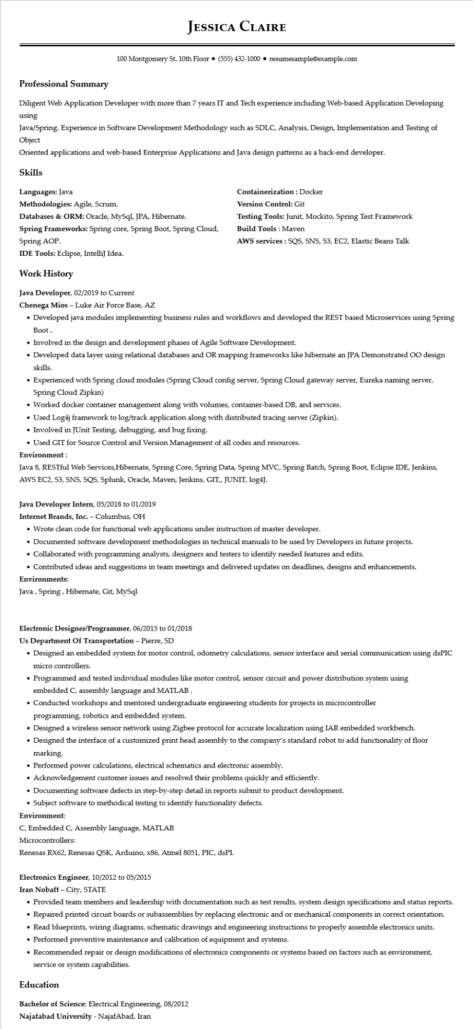
Professional Summary
JESSICA CLAIRE
100 Montgomery St. 10th Floor⚫ (555) 432-1000⚫ resumesample@example.com
Diligent Web Application Developer with more than 7 years IT and Tech experience including Web-based Application Developing using
Java/Spring. Experience in Software Development Methodology such as SDLC, Analysis, Design, Implementation and Testing of Object
Oriented applications and web-based Enterprise Applications and Java design patterns as a back-end developer.
Skills
Languages: Java
Methodologies: Agile, Scrum.
Databases & ORM: Oracle, MySql, JPA, Hibernate.
Spring Frameworks: Spring core, Spring Boot, Spring Cloud,
Spring AOP.
IDE Tools: Eclipse, IntelliJ Idea.
Containerization: Docker
Version Control: Git
Testing Tools: Junit, Mockito, Spring Test Framework Build Tools: Maven
AWS services: SQS, SNS, S3, EC2, Elastic Beans Talk
Work History
Java Developer, 02/2019 to Current
Chenega Mios - Luke Air Force Base, AZ
• Developed java modules implementing business rules and workflows and developed the REST based Microservices using Spring Boot.
• Involved in the design and development phases of Agile Software Development.
• Developed data layer using relational databases and OR mapping frameworks like hibernate an JPA Demonstrated OO design skills.
• Experienced with Spring cloud modules (Spring Cloud config server, Spring Cloud gateway server, Eureka naming server, Spring Cloud Zipkin)
• Worked docker container management along with volumes, container-based DB, and services.
• Used Log4j framework to log/track application along with distributed tracing server (Zipkin).
• Involved in JUnit Testing, debugging, and bug fixing.
• Used GIT for Source Control and Version Management of all codes and resources.
Environment:
Java 8, RESTful Web Services, Hibernate, Spring Core, Spring Data, Spring MVC, Spring Batch, Spring Boot, Eclipse IDE, Jenkins, AWS EC2, 53, SNS, SQS, Splunk, Oracle, Maven, Jenkins, GIT,, JUNIT, log4J.
Java Developer Intern, 05/2018 to 01/2019
Internet Brands, Inc. - Columbus, OH
• Wrote clean code for functional web applications under instruction of master developer.
• Documented software development methodologies in technical manuals to be used by Developers in future projects.
• Collaborated with programming analysts, designers and testers to identify needed features and edits.
• Contributed ideas and suggestions in team meetings and delivered updates on deadlines, designs and enhancements. Environments:
Java, Spring, Hibernate, Git, MySql
Electronic Designer/Programmer, 06/2015 to 01/2018
Us Department Of Transportation - Pierre, SD
• Designed an embedded system for motor control, odometry calculations, sensor interface and serial communication using dsPIC micro controllers.
• Programmed and tested individual modules like motor control, sensor circuit and power distribution system using embedded C, assembly language and MATLAB.
• Conducted workshops and mentored undergraduate engineering students for projects in microcontroller
programming, robotics and embedded system.
• Designed a wireless sensor network using Zigbee protocol for accurate localization using IAR embedded workbench.
• Designed the interface of a customized print head assembly to the company's standard robot to add functionality of floor marking.
• Performed power calculations, electrical schematics and electronic assembly.
• Acknowledgement customer issues and resolved their problems quickly and efficiently.
• Documenting software defects in step-by-step detail in reports submit to product development.
• Subject software to methodical testing to identify functionality defects.
Environment:
C, Embedded C, Assembly language, MATLAB
Microcontrollers:
Renesas RX62, Renesas QSK, Arduino, x86, Atmel 8051, PIC, dsPI.
Electronics Engineer, 10/2012 to 05/2015
Iran Nobaft City, STATE
• Provided team members and leadership with documentation such as test results, system design specifications and status reports. Repaired printed circuit boards or subassemblies by replacing electronic and or mechanical components in correct orientation.
• Read blueprints, wiring diagrams, schematic drawings and engineering instructions to properly assemble electronics units.
• Performed preventive maintenance and calibration of equipment and systems.
• Recommended repair or design modifications of electronics components or systems based on factors such as environment, service or system capabilities.
Education
Bachelor of Science: Electrical Engineering, 08/2012
Najafabad University - NajafAbad, Iran

